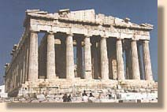
When and why was the Parthenon built?
2500 years ago, the city of Athens was attacked by soldiers from Persia. The Athenians had to leave their city. Eventually they managed to defeat the Persians but Athens was now a ruin. It would have to be rebuilt. The man who took charge of rebuilding Athens was called Pericles. He got all the best architects, sculptors and other craftsmen together and they rebuilt Athens. It was full of wonderful buildings. But the best building of all was the Parthenon.
Information from: http://greece.org/parthenon/marbles/children.htm

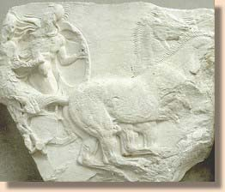
What was the Parthenon?
The Parthenon was a temple to the goddess Athena. It was built on top of a hill called the Acropolis. You could see it from all over Athens. Inside the Parthenon there was a huge statue of the goddess Athena. Outside the Parthenon, high up on its four walls there was a frieze. This frieze was a series of sculptures that went all the way round the building. These sculptures were not added to the building. The sculptors actually cut the frieze out of the very stone which formed the walls of the building. Many people think that this frieze is one of the most wonderful works of art ever created.
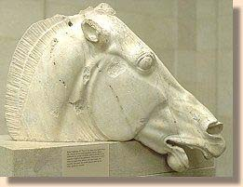
What happened to the Parthenon?
The Parthenon did not remain a temple to Athena for ever. The statue of Athena was destroyed. When Europe became Christian, the temple was turned into a church. Later, the Turks took over Athens and they turned it into a mosque. However, the building survived for hundreds and hundreds of years. Then in 1687 an Italian general called Francesco Morosini arrived in Athens. He was at war with the Turks. He fired on the Acropolis. He knew that the Turks were using the Parthenon as an arsenal -- where weapons are stored. The Parthenon was full of gunpowder. One of the shells fired by Morosini landed in the Parthenon and all the gunpowder exploded. This did terrible damage to the Parthenon. The roof was blown off and everything inside was destroyed. But, as if by a miracle, the frieze survived.
Who was Lord Elgin?
Elgin was a Scottish Lord who hoped to do well in politics. At the beginning of the 19th century Lord Elgin was appointed ambassador to the Ottoman Empire. The capital of the Ottoman Empire was in Istanbul in what is now called Turkey. At that time relations between Britain and Turkey were very good. Why? Egypt had been part of the Ottoman Empire until Napoleon, the French general, defeated the Turks and occupied Egypt. The British defeated Napoleon and the French left Egypt. As a result the Turks were very grateful to the British.
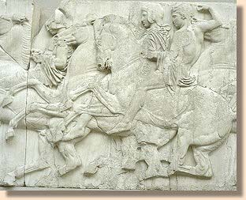
Why did Elgin take the Marbles?
Lord Elgin wanted to find some ancient Greek statues to decorate his mansion in Scotland. He travelled in Greece, looking for things to send back to Britain. He employed an artist to make drawings of Greek statues and buildings. When he came to the Acropolis he was given permission to remove anything which was lying on the ground. But Elgin decided to take the statues of the Parthenon frieze and send them back to England.
As I explained above, this frieze was actually part of the building. It wasn't stuck on. So in order to take the frieze, Elgin had to get workmen to saw the frieze off the building. It also involved destroying parts of the building in order to lower the sculptures to the ground. Elgin did a lot of damage to the Parthenon building.
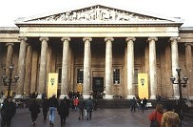
Elgin took about half of the frieze and some other sculptures from the Parthenon. He sent them back to England. After that things went very badly for Elgin. He found himself so short of money that he decided to sell the Parthenon Marbles to the British government. Some Members of Parliament thought that Elgin had done a terrible thing in removing the Parthenon Marbles. However, it was decided to buy the Parthenon Marbles from Elgin and put them in the British Museum. And they have stayed there ever since.
Why didn't the Greeks stop Elgin?
When Elgin took the Parthenon Marbles, Greece was not an independent country. It was part of the Ottoman Empire. The Turks ruled in the lands of the Greeks. So the Greeks were not able to stop Elgin from taking the Marbles. Twenty years later the Greeks started a war of independence and soon Greece became an independent country. Immediately the Greeks demanded the return of the Parthenon Marbles, but their request was refused.
The Campaign for the return of the Marbles to Athens
In the early 1980s, a famous Greek actress called Melina Mercouri became Minister of Culture in the Greek government. She began the campaign for the return of the Parthenon Marbles. That campaign continues today, although Melina Mercouri died in 1994.

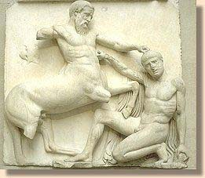
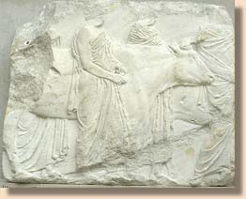
Arguments in favour of returning the Parthenon Marbles to Greece
1. The Parthenon Marbles were stolen from Greece by Lord Elgin. Elgin did not have permission to cut sculptures from the Parthenon. He only had permission to take pieces that were lying on the ground.
2. It is wrong that half of the Parthenon Marbles are in London and half are in Athens. They should all be in the same place. They were created in Athens, so they should be on display in Athens.
3. The British Museum has not looked after the Marbles as well as they say they have. In the 1930s the Marbles were cleaned. This cleaning damaged the surface of the Marbles.
Arguments against returning the Parthenon Marbles to Greece
1. If Lord Elgin hadn't taken the Marbles they would have been destroyed by the Turks.
(But is this true? The sculptures Elgin left behind were not destroyed by the Turks).
2. If the Marbles hadn't gone to the British Museum they would have been destroyed by pollution in Athens.
(This is a better argument because the Parthenon did suffer from pollution in the 1950s and 1960s. But the Parthenon Marbles suffered in London. They were stored in a coal shed for many years while Elgin was trying to sell them to the government. The coal shed was very damp and this damaged the Marbles).
3. Many people see the Parthenon Marbles in the British Musuem. If they go back to Athens, fewer people will see them.
(This is not a good argument. The Marbles belong to Greece, not to us. They are stolen property. Also, more and more people travel today and they can go to Athens to see the Marbles).
4. Many people worry that other countries, like Egypt, will want the British Museum to return exhibits taken from their countries and so the British Museum will be emptied of its contents. (However, there are many rooms of exhibits from Greece including large parts of two Greek temples, and the Greek government has said it doesn't want anything back except the Parthenon Marbles. Also the Greek government has offered to lend the British Museum the best of its collection on a rotating basis if the Marbles are returned. Egypt has also declared that it is not seeking the return of Ancient Egyptian exhibits in the British Museum).
What do you think? Send us an email
Do you think that the Parthenon Marbles should stay in London or do you think they should go back to Athens? Write and tell us what you think. If your class has a discussion about the Parthenon Marbles write and tell us the result. To send us an email click here

